**Geographical Information Systems**

**Assignment 2**

|  |
| --- |
| **Student Name:** Mohamed Samy Mahmoud Elgabry |
| **Student ID:** 20190441 |
| **Group No.:** S1 |

**The objective of this assignment is to identify an area " أرض فضاء "in which to build new high school in El Dokki District. This new school must be in an area**

**1. not within 100 meters of the existing schools**

**2. not within 500 meters of the existing hospitals**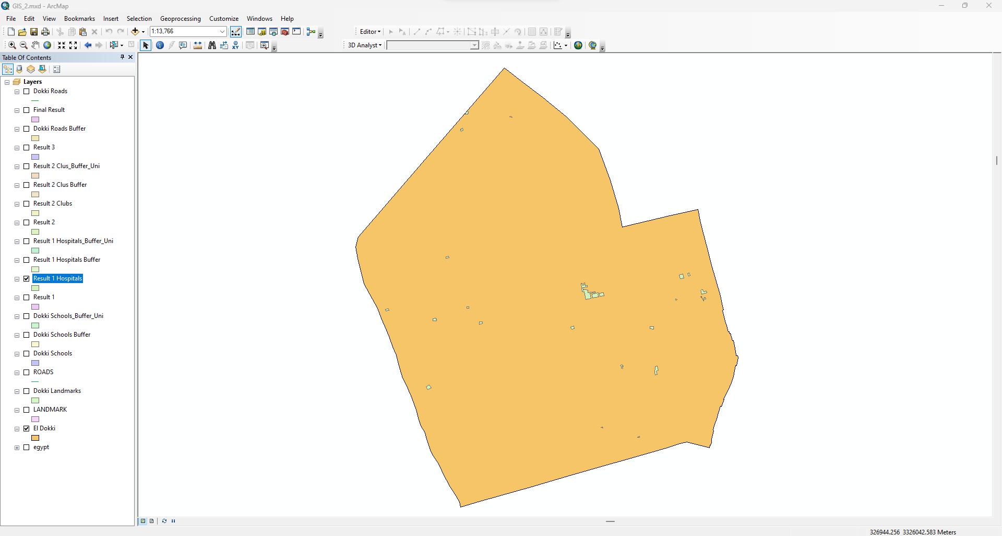

**3. not within 500 meters of the existing Clubs**

**5. with an area of at least 5,000 square meters**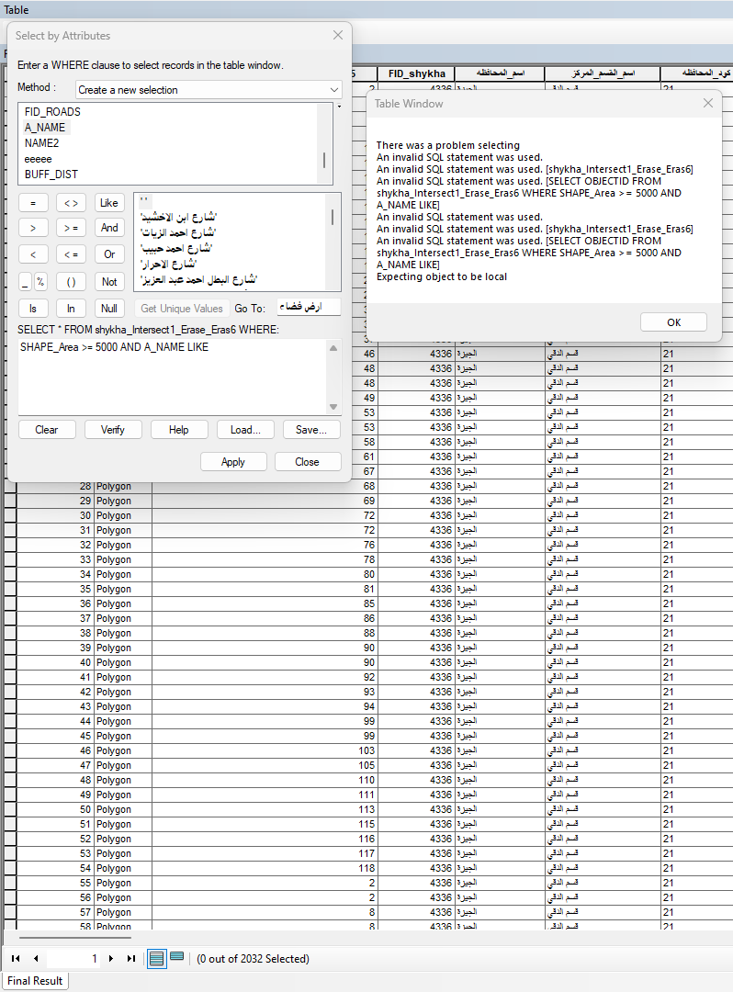

There is no an area " أرض فضاء "in which to build new high school in El Dokki District.